To Validate the presence of MyAccount and absence of Login Link.

**//Defect 2(Explained in Day 11 test case_Solution_SS)**

**Defect2:**

**Assert false is not working,in my code I have commented it and just running assertTrue(to check whether it pass or not)**

**Issue is page is giving Login link that’s why Assert.asserttrue is passed**.

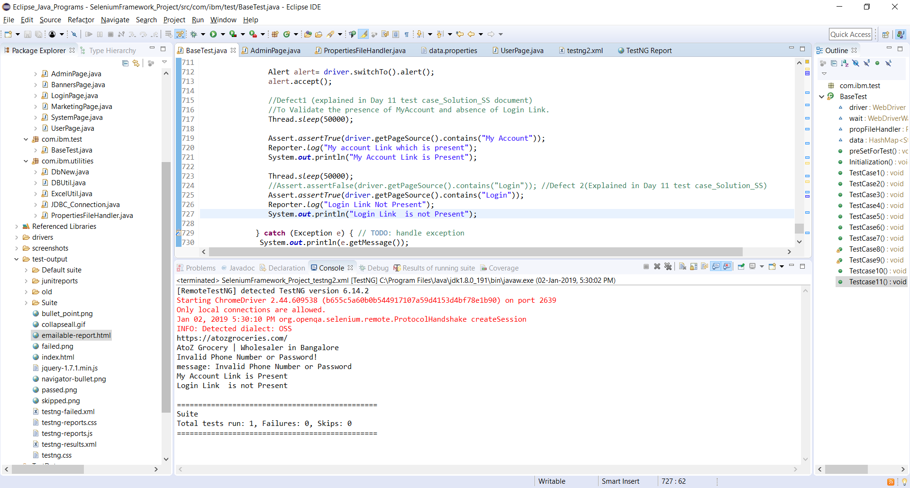

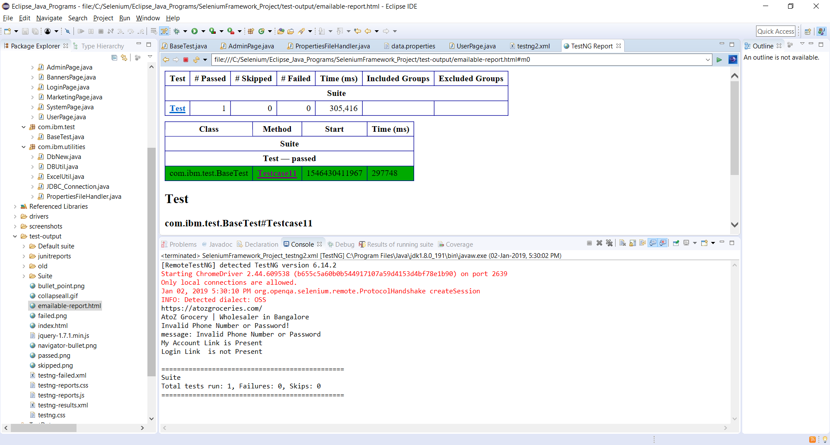

[RemoteTestNG] detected TestNG version 6.14.2

Starting ChromeDriver 2.44.609538 (b655c5a60b0b544917107a59d4153d4bf78e1b90) on port 2639

Only local connections are allowed.

Jan 02, 2019 5:30:10 PM org.openqa.selenium.remote.ProtocolHandshake createSession

INFO: Detected dialect: OSS

https://atozgroceries.com/

AtoZ Grocery | Wholesaler in Bangalore

Invalid Phone Number or Password!

message: Invalid Phone Number or Password

My Account Link is Present

Login Link is not Present

===============================================

Suite

Total tests run: 1, Failures: 0, Skips: 0

===============================================

Validate successful log out with the presence of Login / Sign Up links.

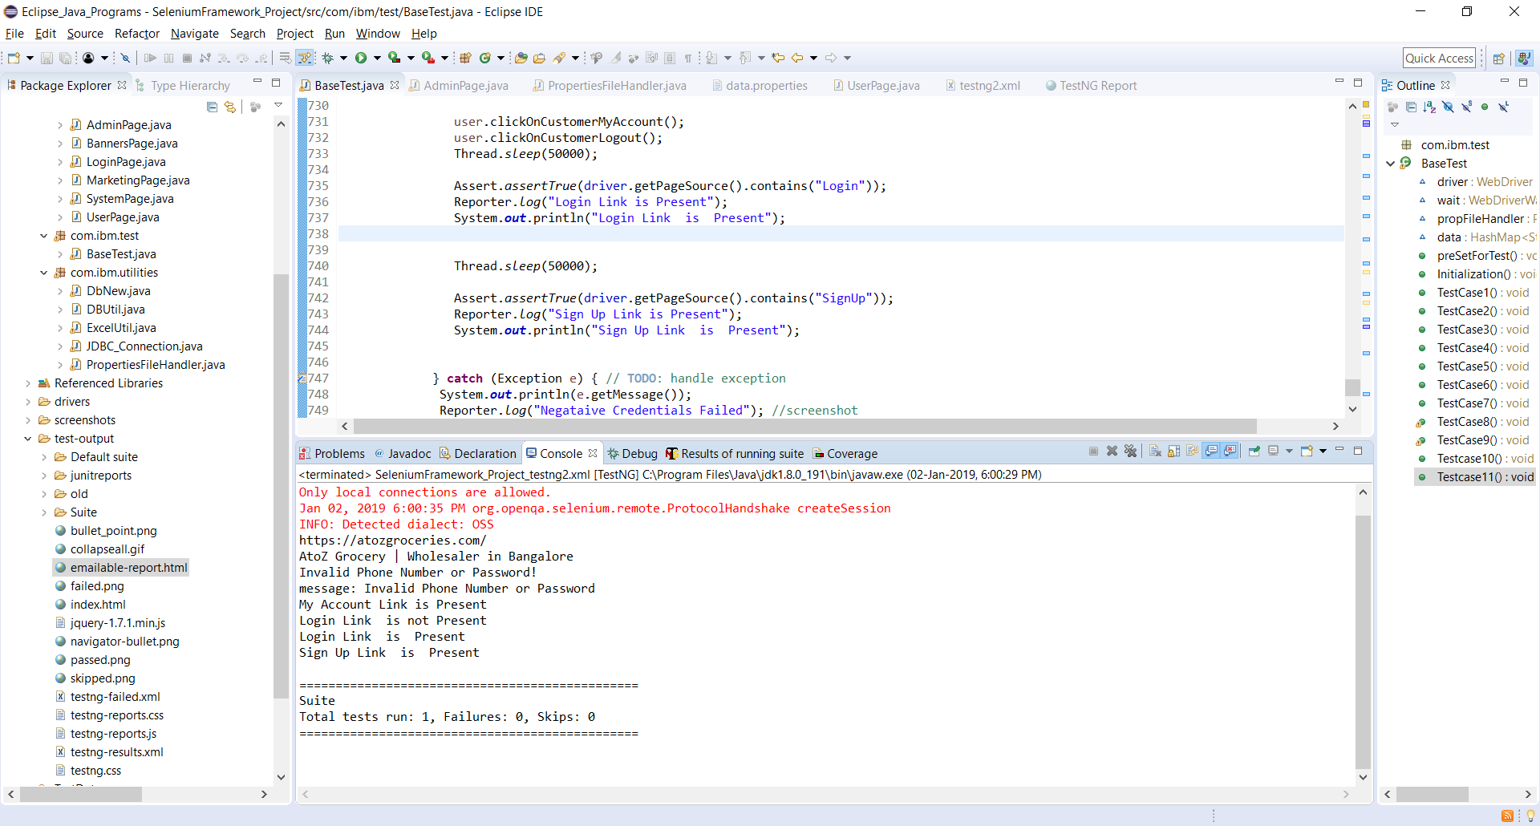

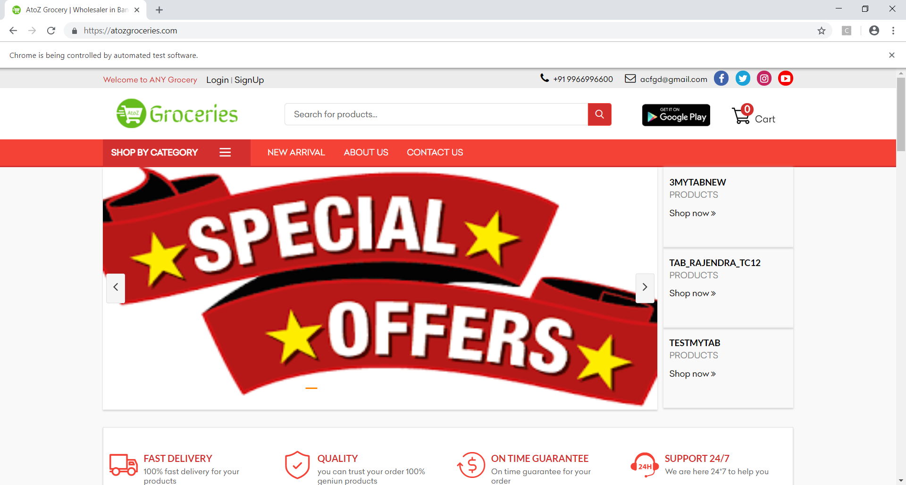

[RemoteTestNG] detected TestNG version 6.14.2

Starting ChromeDriver 2.44.609538 (b655c5a60b0b544917107a59d4153d4bf78e1b90) on port 44626

Only local connections are allowed.

Jan 02, 2019 6:00:35 PM org.openqa.selenium.remote.ProtocolHandshake createSession

INFO: Detected dialect: OSS

https://atozgroceries.com/

AtoZ Grocery | Wholesaler in Bangalore

Invalid Phone Number or Password!

message: Invalid Phone Number or Password

My Account Link is Present

Login Link is not Present

Login Link is Present

Sign Up Link is Present

===============================================

Suite

Total tests run: 1, Failures: 0, Skips: 0

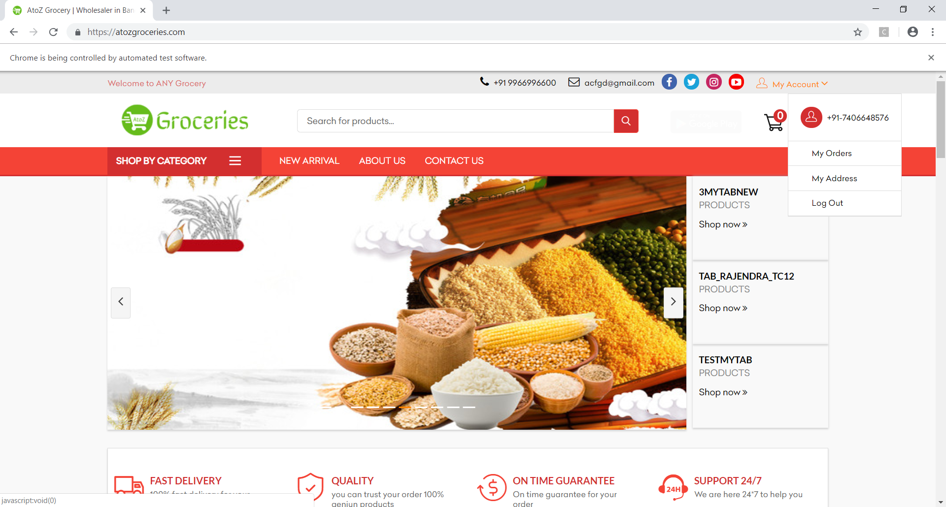

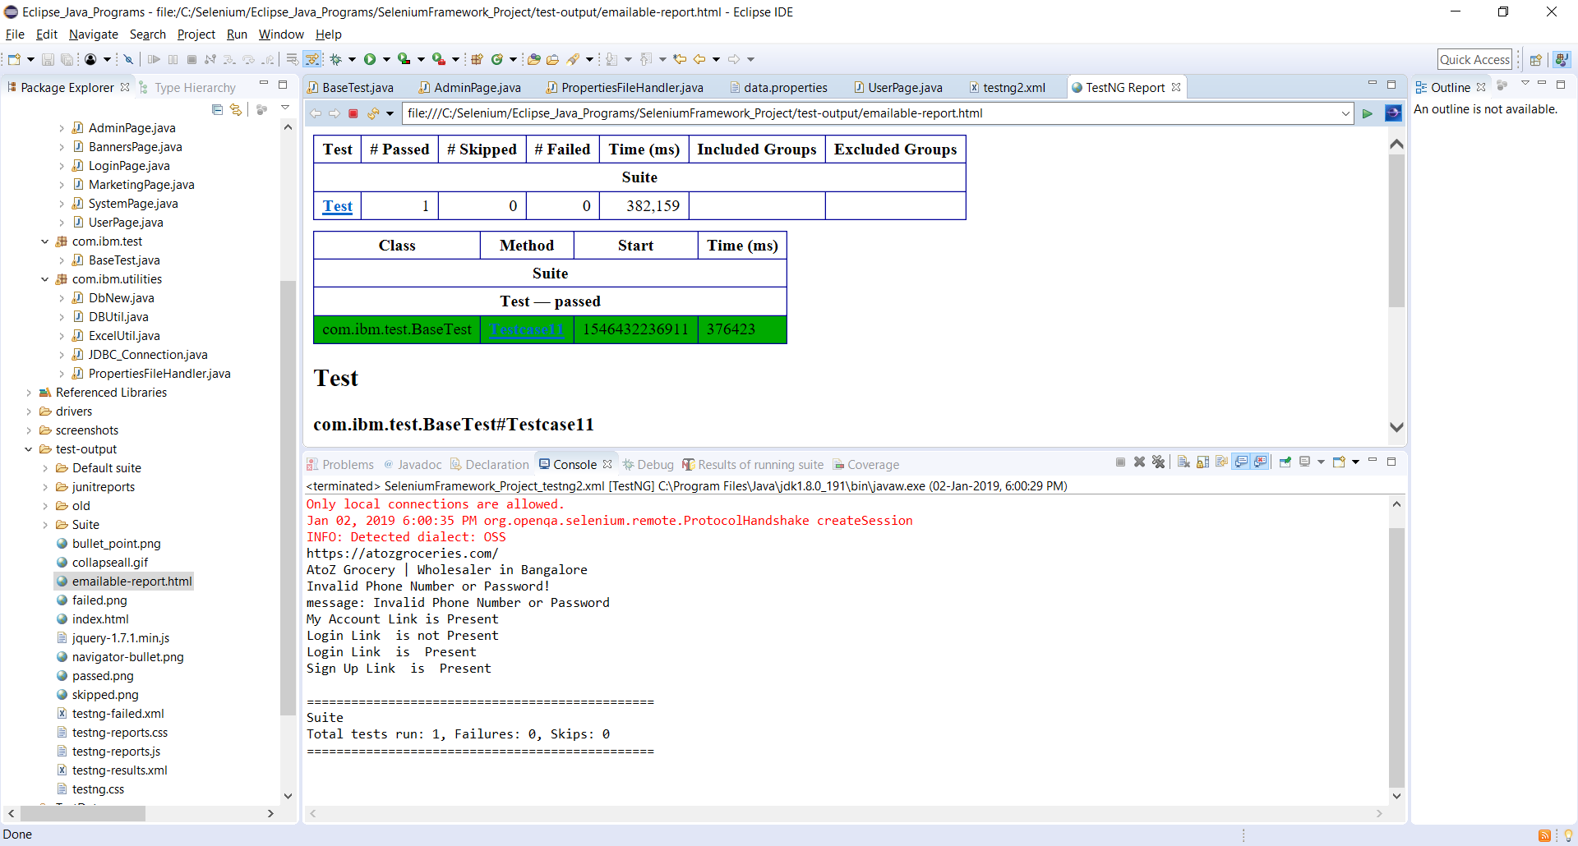

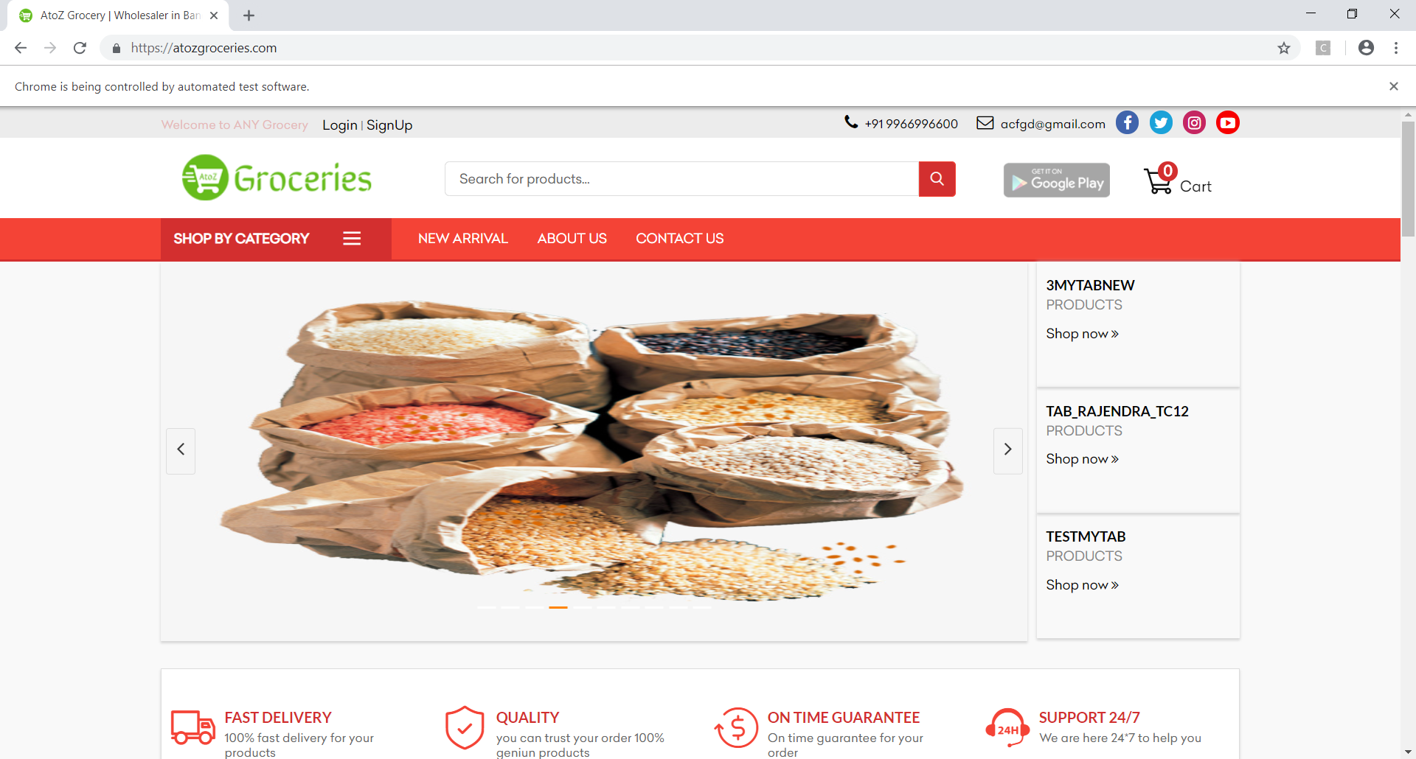

Validate the record in DB

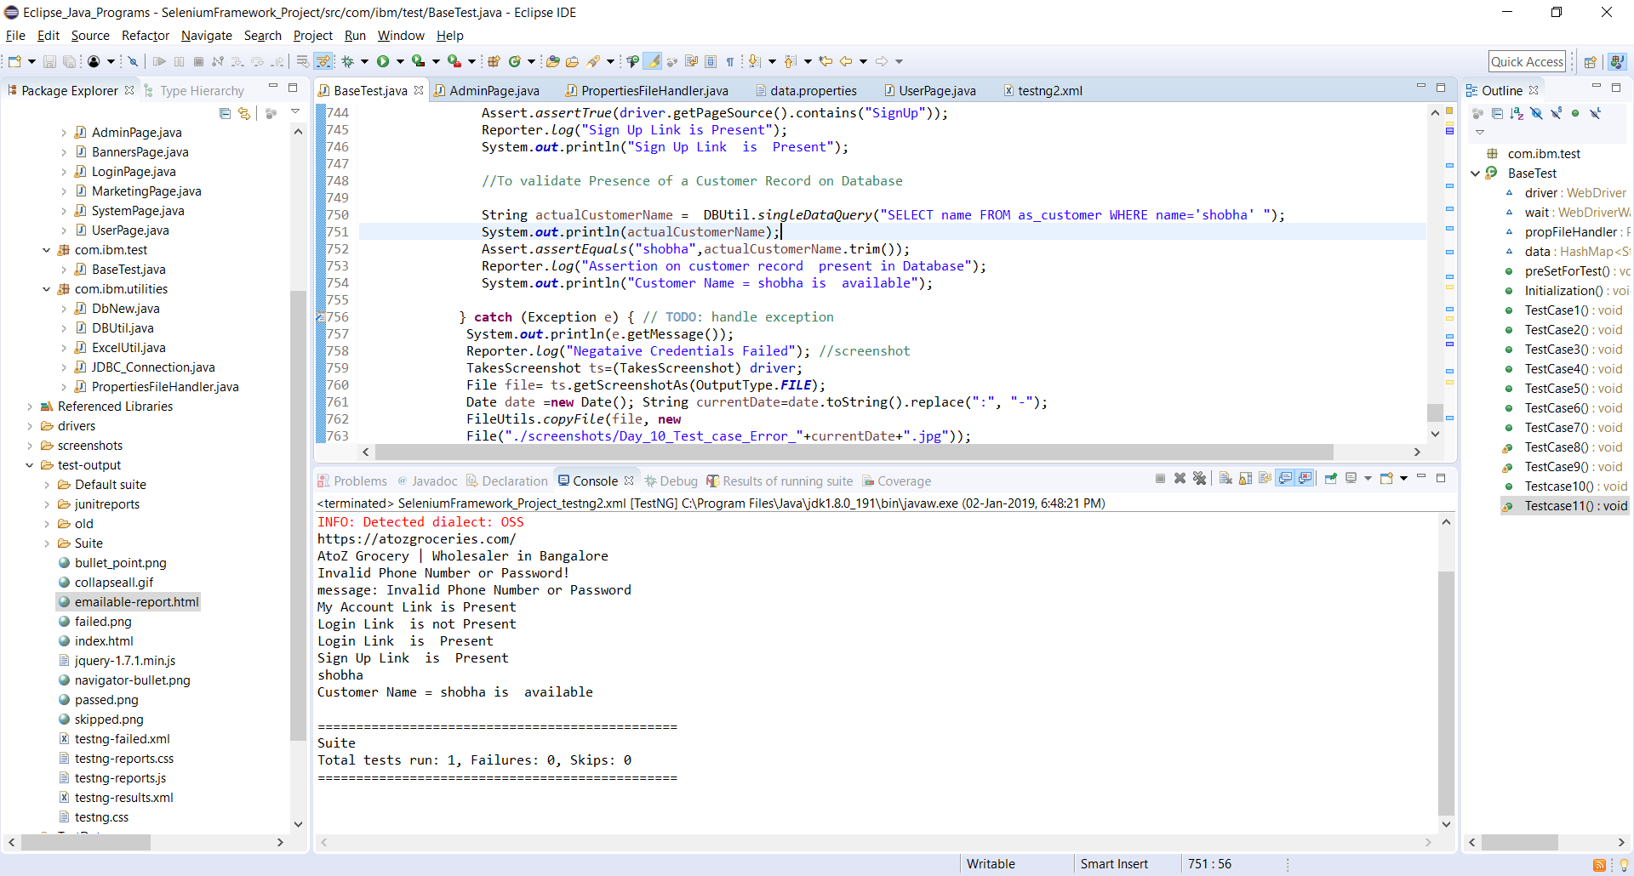

[RemoteTestNG] detected TestNG version 6.14.2

Starting ChromeDriver 2.44.609538 (b655c5a60b0b544917107a59d4153d4bf78e1b90) on port 38106

Only local connections are allowed.

Jan 02, 2019 6:48:28 PM org.openqa.selenium.remote.ProtocolHandshake createSession

INFO: Detected dialect: OSS

https://atozgroceries.com/

AtoZ Grocery | Wholesaler in Bangalore

Invalid Phone Number or Password!

message: Invalid Phone Number or Password

My Account Link is Present

Login Link is not Present

Login Link is Present

Sign Up Link is Present

shobha

Customer Name = shobha is available

===============================================

Suite

Total tests run: 1, Failures: 0, Skips: 0

===============================================

